SMART ASSESSOR - GUIDE FOR LEARNERS
Introduction
In order to meet the criteria for your standard/qualification you will use Smart Assessor, an e-portfolio system, to build up a portfolio of evidence. This guide will hopefully help you to navigate your way around Smart Assessor, however, in addition you will work closely with your Training Adviser who will give you further support and will work with you to ensure that you complete your apprenticeship in a timely manner.
We expect you to take ownership for your own learning/progress, to login to Smart Assessor on a regular basis and you will be expected:
- To familiarise yourself with the criteria you need to work towards throughout your apprenticeship. The Progress Map sets out all of the criteria you will be working towards and will show you what you have completed so far. Your Training Adviser will review this regularly with you and support you with what you need to do next;
- To undertake any learning needed and keep a log of ALL learning both on and off the job, including anything you have learned in day release. You can use the Time Log on Smart Assessor to do this.
- To print off (if applicable) or save any documents you need to complete any actions or activities that have been set for you by your Training Adviser;
- To ensure that all actions and activities are completed by their target dates;
- To provide and add your own evidence to the evidence library when directed;
- To use BKSB, for Functional Skills (if applicable) and to keep a log of any learning.
- To ensure documents requiring electronic signature are signed.

To login to Smart Assessor - Go to www.smartassessor.co.uk - Login with your Username and Password – (you should have received your Username and Password by email, directly from Smart Assessor. If you haven’t please let your Training Adviser know). When you login for the first time a Disclaimer page will appear. Please read and accept.

Below is a brief guide which explains what each of the buttons i.e. icons you see on Smart Assessor represent. Your Training Adviser will give you further training and support on how to use the system and you can click on the Support tab once you are logged into Smart Assessor for user guides and video tutorials.
Once you have logged in you will see different tabs across the top which represent different components of your course. One of the tabs is the Overview page, and should look something like this (if it does not take you automatically to this page just click on the grey Overview tab):

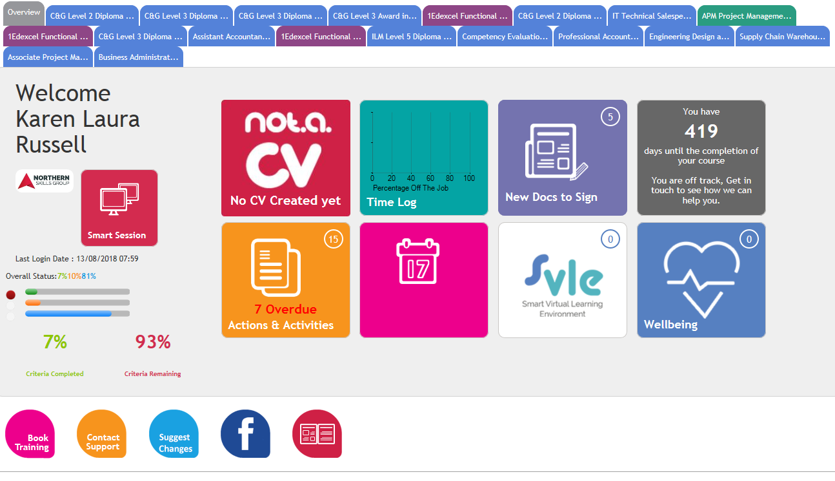

- On the left it will show your name, photograph (if you’ve added one) and your overall progress. On the right it tells you how many days until you have completed your course and whether you are on or off track. (ignore the blue wellbeing icon with the heart in it, we don’t use this feature at the moment).

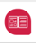
- You don’t need to worry about the Not A CV or SVLE icons. We are not using these icons at the moment. If you are asked to add your CV and/or job description click on the icon. You can either fill in the boxes or upload them at the bottom.

- The pink icon in the middle of the bottom row will show you the date and time of your next planned session. This will also appear at the bottom of the screen. You can see in the example above that this particular learner has no sessions currently booked.

- Time Log – this is where you can log learning, no matter how small including what you have learned at day release.
When you click the Time Log button (or there is a Time Log tab at the top) it will open up the following screen. Click on “Add New Timelog Entry” to add new learning:
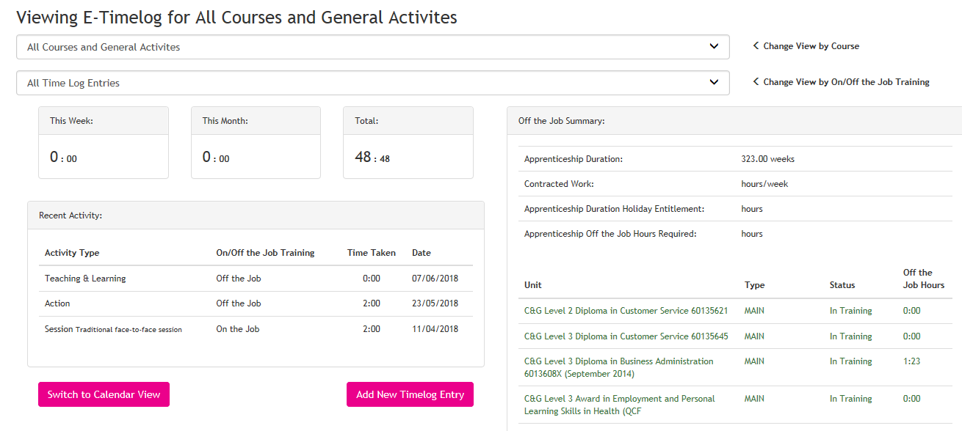
- Select Date when learning took place
- Activity Type – see table below
- Select Course and Unit (if applicable)
- Select Assessor or No Assessor, depending on the activity type i.e. was your assessor involved in the learning?
- Select on or off the job – see table below
- Select the amount of hours and minutes spent on the activity
- Add comments to give the details of what you have actually learned and how you have done this. Please also reflect on how this new learning will impact on your job role, i.e. what can you do better as a result of this?
Once complete click on Add Activity to save. You can switch between Calendar View and List View to see and edit your entries. To edit click on the yellow pencil or if you wish to delete click on the cross.
Activity Type | Use this for… | On or off the job
Traditional face-to-face session | Time spent 1:1 with your Training Adviser – this will log automatically and your Training Adviser will update this with you. | Off the job
Trainer or assessor led training | Learning at day release | Off the job
Electronic or distance learning or self-study | Work on any actions/activities set (including those set on Smart Assessor, during day release and bKSB) e.g. workbooks, assignments, research, written questions etc | Off the job
Coaching or mentoring | Mentoring or workshadowing | Off the job
Gaining technical experience by doing my job | Following 1:1 instructions to complete a new task i.e. learning as you are doing your job. | On the job
Review/feedback/support | Learning from 1:1 meetings with your Manager, appraisals, feedback from your Manager, etc. | On the job
Assessment or examination | Learning from reflecting on any exams or assessments you have taken | Off the job

Once saved, to view or edit any activity, you can use the drop down boxes to view by course and/or on/off the job. At the bottom of the screen there is the option to export this information to Excel.
- New Docs to Sign – sometimes your Training Adviser might need you to electronically sign some documents. These will sit in this folder and, if you have any documents outstanding, a number will appear in this icon. The example above states that this learner currently has two documents awaiting signature. To sign off your documents, click on this icon. It will take you to a list that looks something like this:

You can click on Open Doc to view the document then click on Sign to sign the document. If you click on Sign then the following screen will appear:

Tick the box where it says Learner (see above) and then click on Save. The number in your New Docs to Sign icon should now have changed (you might need to refresh your screen).

- Actions & Activities – Your Training Adviser will set you some tasks to complete as actions and/or activities. This icon will tell you how many you have outstanding. If you click on this icon a page similar to the following will appear:

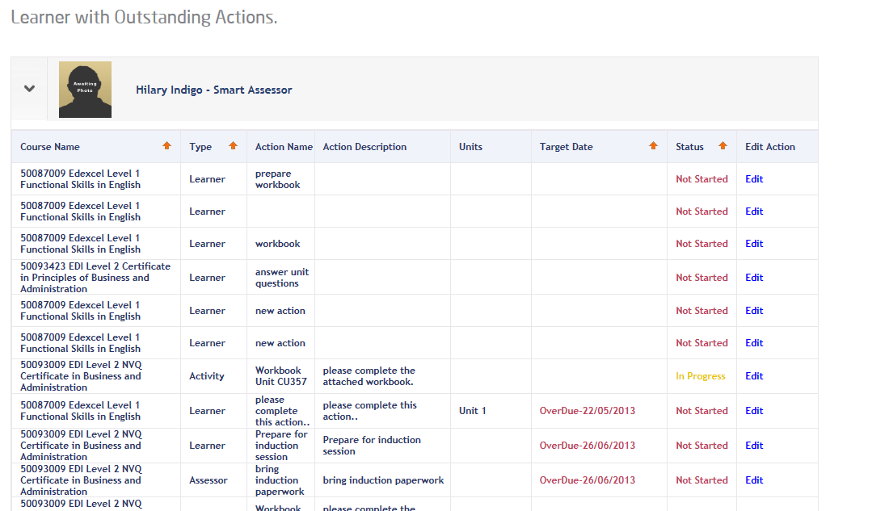

When you complete an action, click on Edit and leave some feedback where it says learner feedback, for example, “I’ve completed this workbook and added it to the evidence library ready for assessment”; add any time spent (if applicable) and update the status to In Progress. IMPORTANT: Please refer to Learning Plan later in this document for more information about Actions and Editing Actions.

We have now covered all of the icons on the Overview page.

Moving on now from the Overview page you will see that there are coloured tabs with the different components that make up your standard/framework, for example, Diploma, functional skills etc. If you click on one of these tabs it will take you to the following screen:
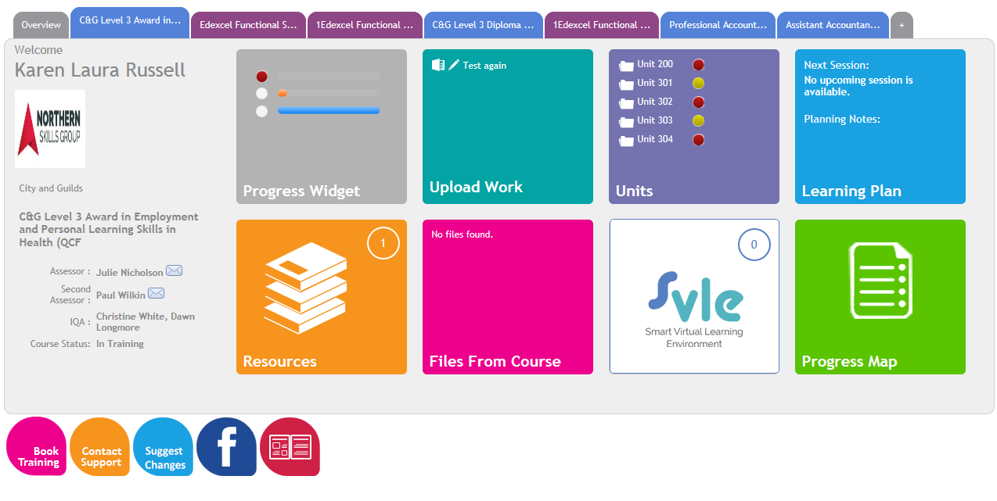
- On the left it tells you the name of the component you are in, and gives the name of your Assessor and IQA. If you need to send an email to your Training Adviser, click on the envelope icon under the Assessor’s name and it will take you to the following screen:
Type in your Subject Heading and Message (just as you would if you were sending an email normally) and then click on Submit, this will send the email directly to your Training Adviser. Please note: you cannot send any attachments. If you have work that needs to be assessed this should be sent via the Evidence Library i.e. Upload Work tab.
- Progress – the grey Progress icon will take you to your Portfolio Dashboard where you can check your progress and access your Record of Achievement for each component of your framework. The screen will look something like this:

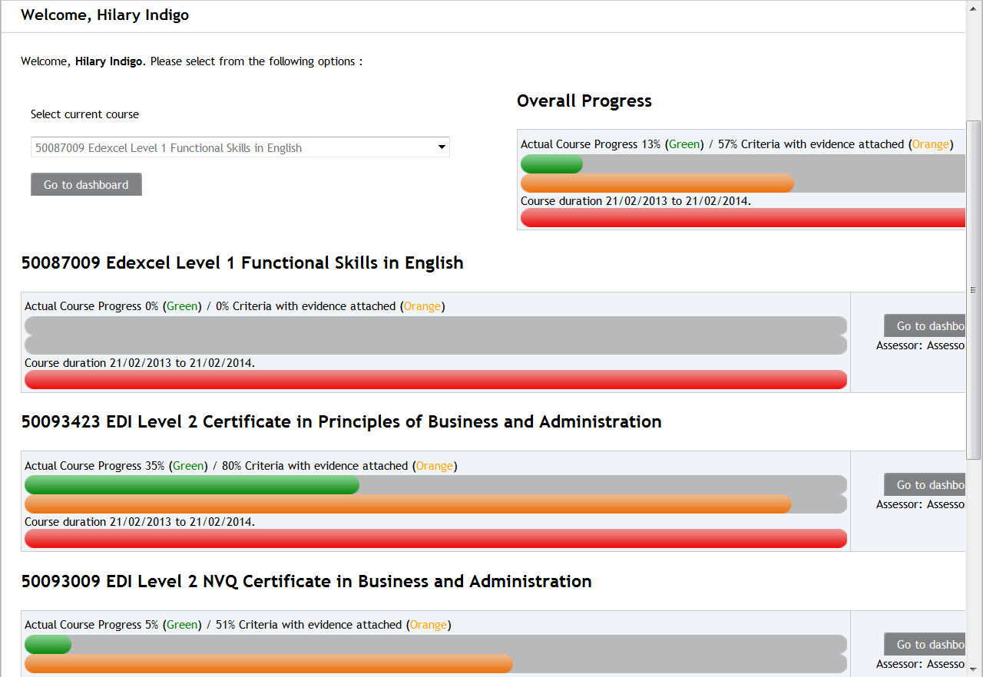

The top progress bar (green) shows you how much of each component you have completed, the middle (orange) shows you how much you have partially completed and the bottom bar (which will be blue if you are currently in training or red if you go over your expected planned end date) shows how far you are through your course duration. You can see your progress against each component and also you can see your overall progress for the whole framework which is at the top right of the page.

- Upload Work – If your Training Adviser asks you to add any documents as evidence for assessment this is where you go to do this. This is often referred to as the Evidence Library. Click on Upload Work, browse, attach the document and upload. IMPORTANT: Make sure that when you are adding evidence that you are in the correct component, for example, if your evidence applies to NVQ add it to the NVQ component only. To do this, click on the drop down box and select the course/component you want to add the evidence to. If you need more help with this, then please ask your Training Adviser to show you what to do. Give your evidence a title and description, tick to declare that this is your own work, tick next to learner to electronically sign, BUT do not complete any other information. Your Training Adviser will do this.

Points for Improvement/Re-submitting evidence – if you send evidence to your Training Adviser and they give you Points for Improvement i.e. ask you to add more information or to make some changes you will receive an email asking you to Re-Submit your work. To do this go back into the evidence library (as above) and find your original evidence that you previously added. You will see a green arrow with an orange box around it (next to the yellow pencil and tick). See below:
Click on this box and it will open and the following box will appear:

Click on Choose File and Upload to upload your amended document to here and write a comment in the box to let your Training Adviser know what you’ve done. Then click on Save. Your Training Adviser will then receive notification that you’ve resubmitted your evidence ready for assessment.

- Units – when you click on this icon it will take you to your Unit Progress page for this component and will show you the overall progress you are making for each unit. Your Training Adviser will give you more information about this.
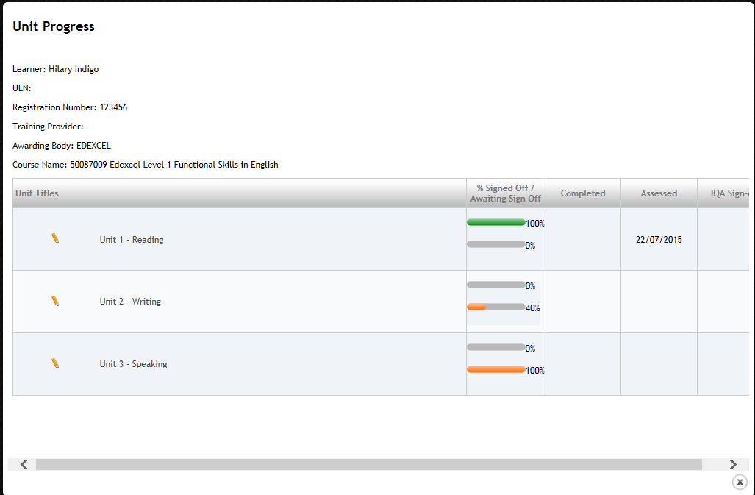

- Learning Plan – Every time your Training Adviser visits you they will add this as a session to your Learning Plan. When you click on this icon it will give you a list of all planned and completed sessions. Click on the chevron to the left of each session to expand that individual session so you can read the contents. You will see from the example below that Session 1 and Session 2 have been expanded, Session 3 is still closed:

Under each session your Training Adviser will tell you what they plan to cover at that session (i.e. Planning Notes) and once the session is over will give you feedback (i.e. Session Feedback). Any documents that relate to that session such as a 12-week progress review, or evidence, will be saved by your Training Adviser to the right of that session and can be opened by clicking on the attached files. You will see in the example above that in Session 1 there is a document attached to ILP (Individual Learning Plan).

Your Training Adviser will also set you some work to do at every visit and will add these as Activities and/or Actions, for example, assignments such as workbooks or questions that they want you to complete by a specific target date. If you look at Session 1 above this will give you an example of what this would look like. You can access a list of all outstanding activities/actions via the overview tab but any files that you would need, would need to be accessed from the Learning Plan.

Your Training Adviser should also write in the description box what they want you to do.

If you’re being asked to complete a workbook or questions these will be attached under Files (see below). You can open the files by double clicking on them but you will need to save them to your computer or USB memory stick if you want to make any amendments to them.

When you have completed or amended your document you will need to re-submit it to your Training Adviser. To do this, either click on the Evidence button in the Action column (if this option is available – the example above doesn’t have this option selected), or add as evidence to the Evidence Library i.e Upload Work as per previous instructions for uploading or re-submitting evidence. Your Training Adviser will change the status to complete once he/she is satisfied that you have met the criteria for that piece of work.

You’ll notice that for Session 1 below there is a Red speech bubble above Session Feedback but in Session 2 the speech bubble is Green.
If the session has a Red speech bubble next to it, this means there are actions or activities to complete. If the speech bubble is Green then there are no actions or activities outstanding against that session. The status of actions and activities is traffic light coded:
Red - Outstanding and to complete.
Yellow - In Progress, in other words, you have started but additional evidence is still required.
Green - This means complete, assessed (if applicable) and closed. In other words, no further action needed.

- Resources – If your Training Adviser adds materials/resources to Smart Assessor that you need for your course there will be a number in this icon. Click on this icon to access any resources saved.

- Files from Course – As Resources above. Any additional files your Training Adviser thinks you will need will be added here.

- Progress Map – This is often referred to as a Gap Analysis. Click on this icon to see your “standards”, in other words, the units and criteria you need to meet in order to complete this particular component. You need to familiarise yourself with these criteria and it is recommended that you print off an updated copy for every visit and your Training Adviser will go through this with you.

As you add evidence to your portfolio the gaps on the Progress Map will change colour from red to orange to green. Red means that you haven’t submitted any work for these areas yet, orange means that you have partially completed these areas but still have more to do and green means these criteria have been signed off and you no longer need to do any more work on these areas. To print off a Progress Map showing what you have left to do, change the filter at the top to Non Completed Criteria, scroll to the bottom and export to PDF, then print off as normal.

- Create a CV – If your Training Adviser asks you to upload your CV and/or Job Description or to create a CV, click on the red icon that looks like a book at the bottom of your screen next to the Facebook icon and you can either complete your personal profile (remember to save after each section) or attach a current, up to date, CV by scrolling to the bottom of the page and uploading. If your Training Adviser asks you to add a job description or company profile to your portfolio, then you can also add these documents onto this page. You can attach any documents by scrolling down to the bottom of the screen and clicking on browse and then upload.

If you need any further support or guidance on how to use the system effectively then please discuss with your Training Adviser, who will be happy to give you some additional support.

